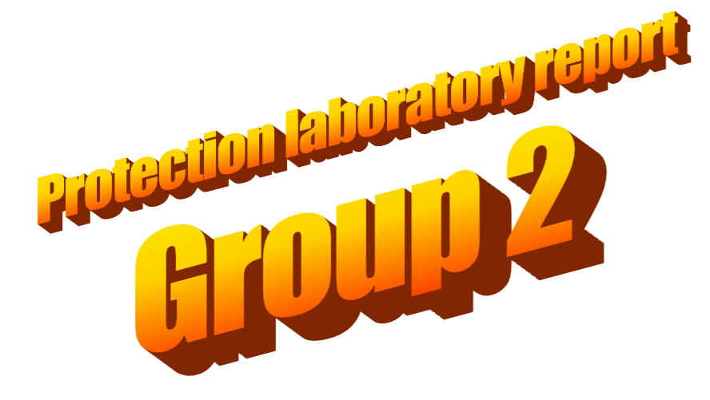

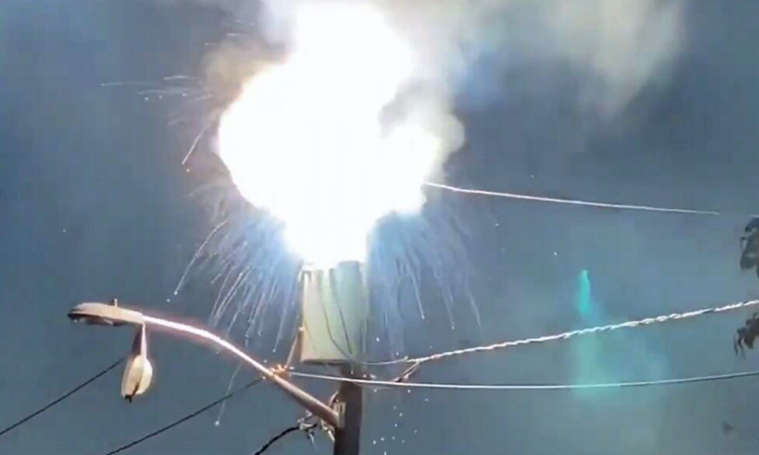

## A brief description of the two activities carried out during the laboratory session

Activity1:

Using SFT2841 software in the lab PC LAN connected with our SEPAM with known IP address.  
We configured our SEPAM’s RELE short-circuit and overloads protection levels (voltage and time), the reaction time and voltage trip levels were tested in the lab and confirmed to be working.  
We acknowledged each RELE trip by noise and error information in the SEPAM screen + leds.

Activity2:

In this lab, the focus is on the intricacies of IEC 61850 communication configuration using the Substation Configuration Language (SCL). The process involves the generation of ICD and CID files, facilitated by tools such as SFT2841 and CET850.

The activity then delves into the activation of **G**eneric **O**bject-Oriented **S**ubstation **E**vent (GOOSE) messages. This entails creating datasets and configuring internal variables for the GOOSE messages using CET850. The configuration involves the establishment of a GOOSE Control Block, configuring the sender (publisher) and the recipient (subscriber) SEPAM devices.

After creating all files, we find ourselves uploading CID files to the SEPAM devices in our LAN network using SFT2841. The subscriber SEPAM is configured to respond to received GOOSE messages, by activating its RELE protection.

## The outcome of the activity proposed below:

Our S12_receiver S82-substation is subscribed to the GOOSE messages for the PTRC1 trigger event status (PTRC1.Tr.general) of the S12_publisher S82-Substation.

As a hypothetical use of this configuration, we could be having a hierarchy of substations, S12 is subscribed and listens for all its substations trips.  
  
When S12 receives only one goose trip from one of its substations, it doesn’t do anything .  
But if more than one substations trip at the same time, S12 RELE opens and isulates the rest of substations from the grid.

